Steven Jimmy Setiwan – 2602114006 – Jockey’s Conference Center

Home Page

Nav Bar  
Navigate Between Page

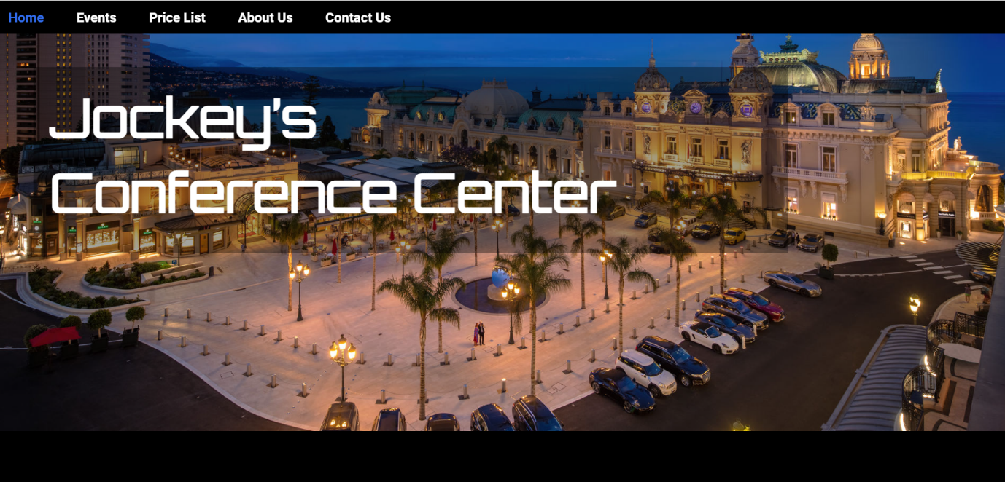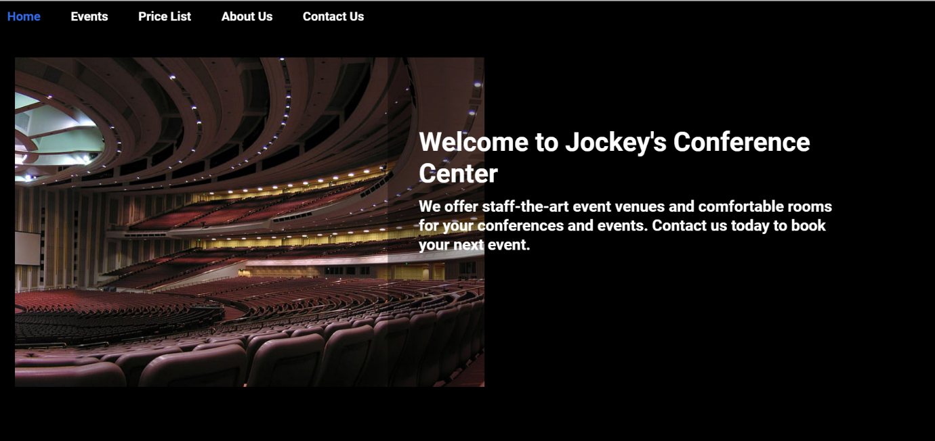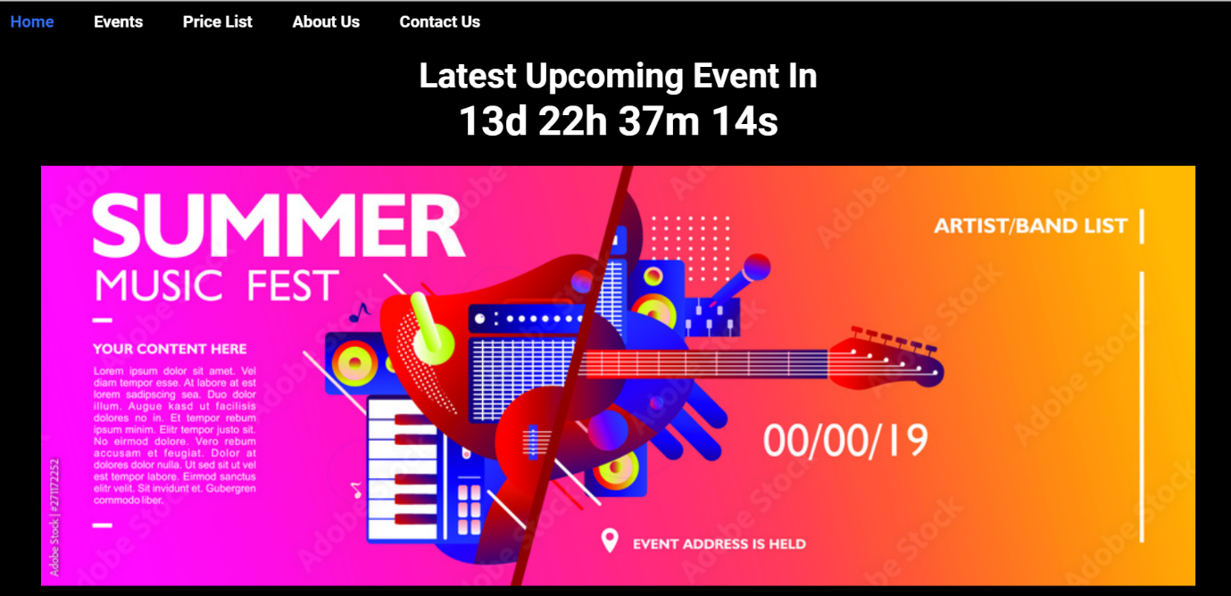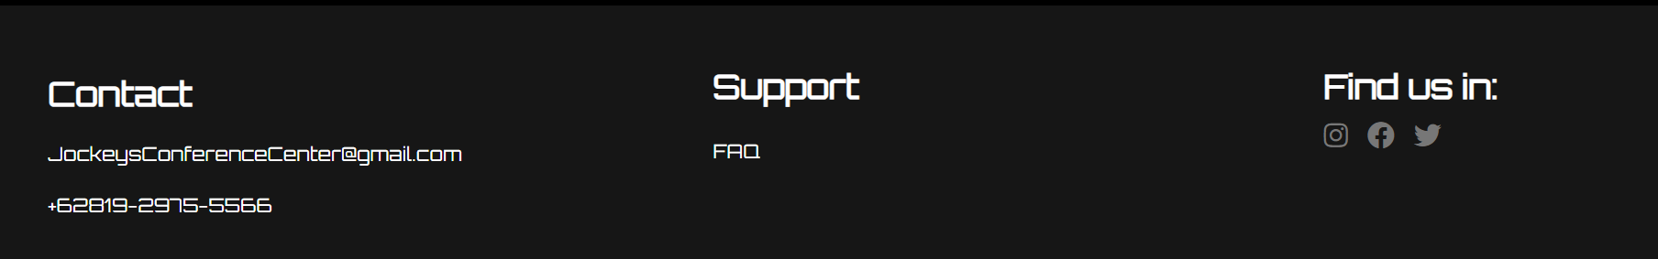

Footer  
Contact Information, FAQ, Social Media

Latest Upcoming Event  
Update everytime the event finished

Introduction

SlideShow  
Glimpse of view inside Jockey’s Conference Center Facilities

Building Pict

Title

Event Page

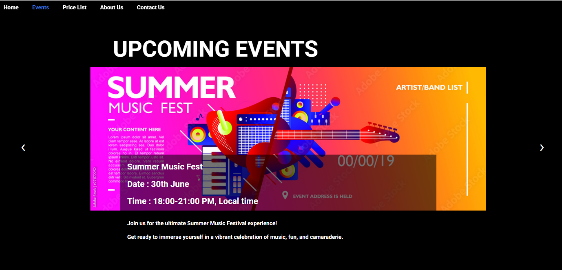

Upcoming Event with a brief information about the event, date and time of the event will be held

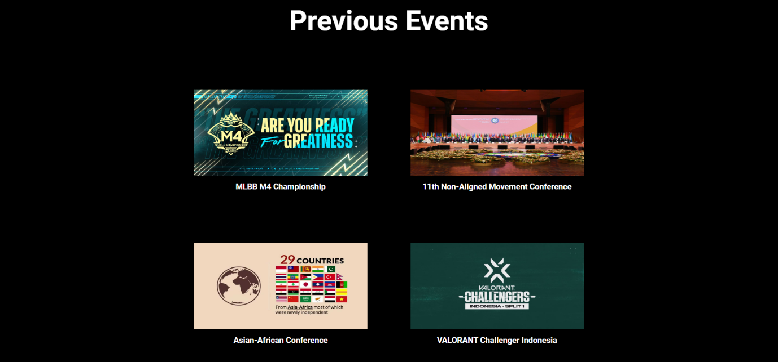

Previous Event Held in Jockey’s Conference Center

Price List Page

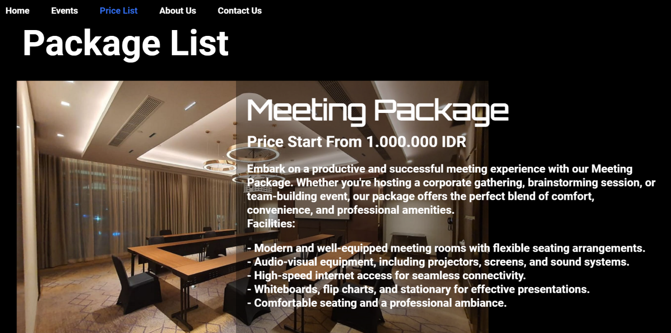

Price List using Package system, Also including the Information about what the package offer

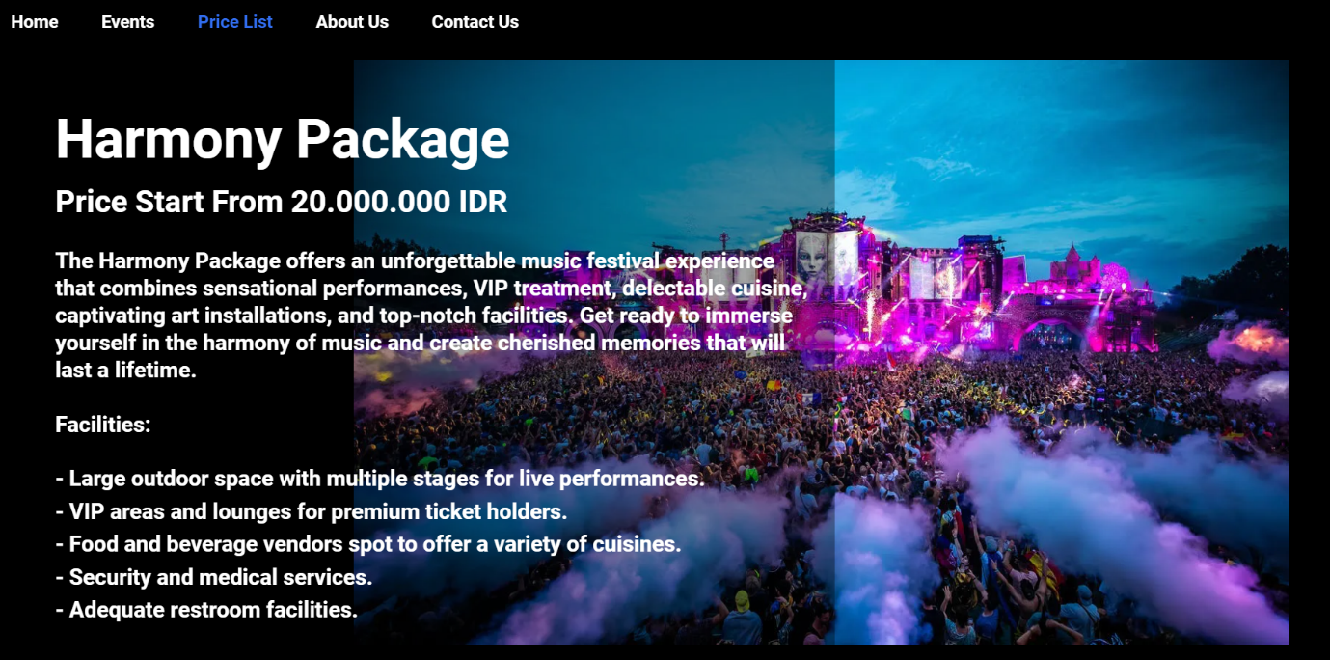

Price List using Package system, Also including the Information about what the package offer

Price List using Package system, Also including the Information about what the package offer

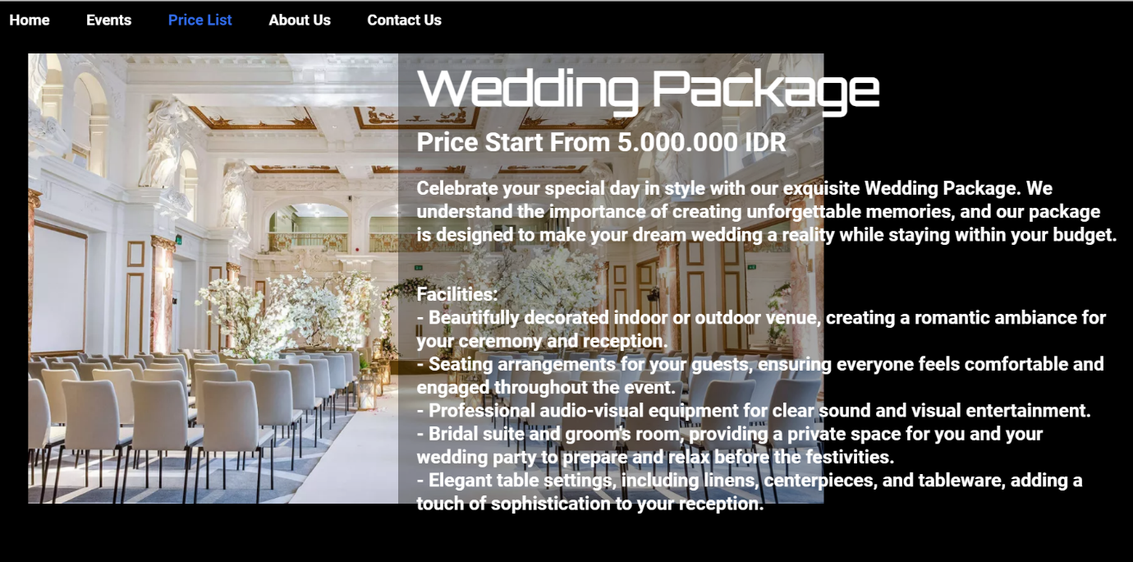

Abour Us Page

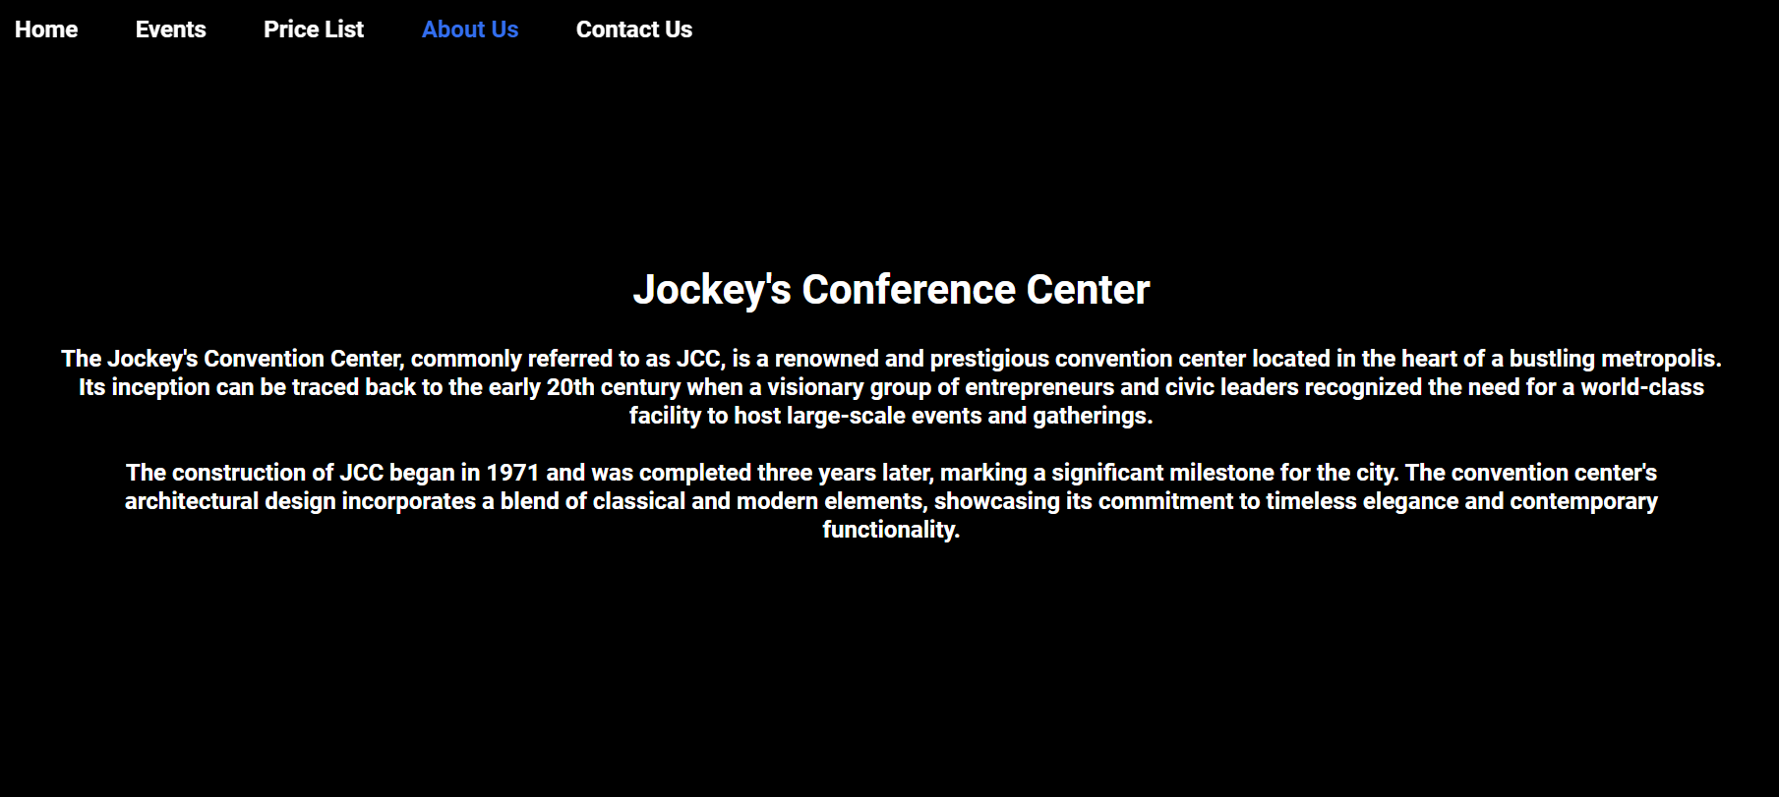

About Jockey’s Conference Center

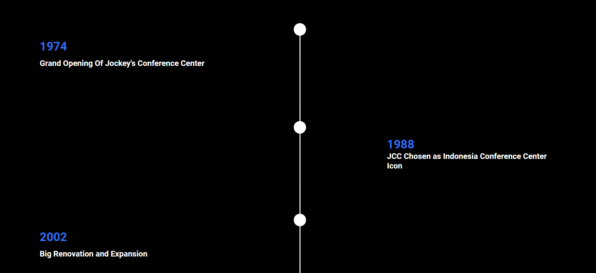

History using TimeLine



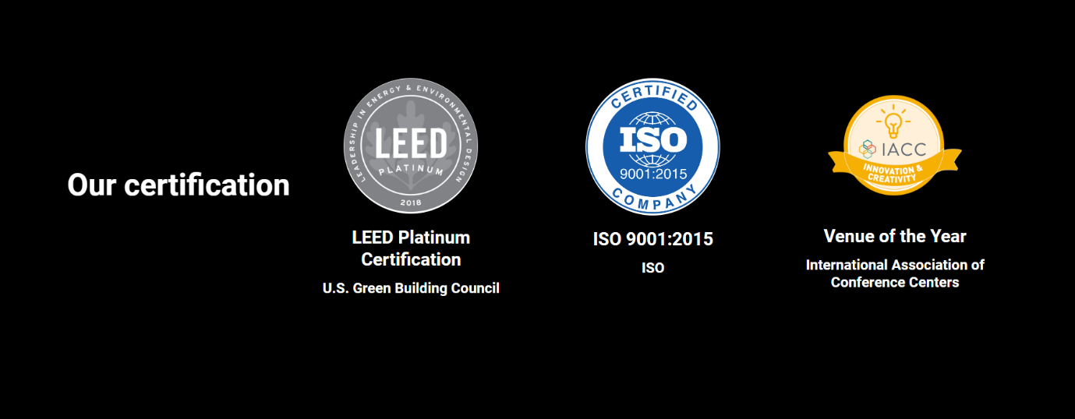

List Of Certification

Contact Us Page

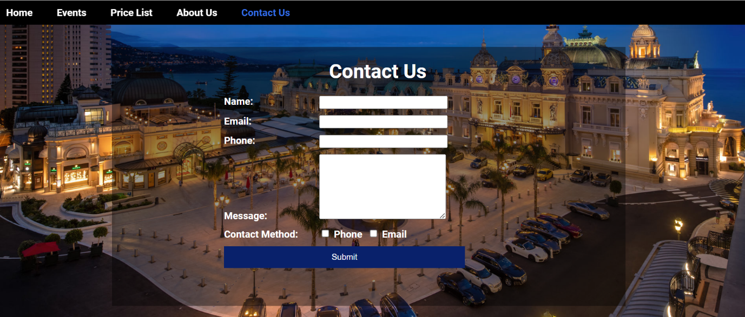

Contact us to gives feedback, critics, suggestion, and booking plan

**Website Flow**

**Knowing about Jockey’s Conference Center**

**Decide to attend or held an event in Jockey’s Conference Center**

**If decide to attend an event, user can go to event page and search for the upcoming event and all the information**

**If decide to held an event, find the package suited for user’s event**

**Contact Us to received more information, discussing about the price, etc**

**References :**

**SlideShow**

**https://www.youtube.com/watch?v=j18CH0Grhbw**

**Validation**

**https://www.youtube.com/watch?v=In0nB0ABaUk**

**ASSETS :**

**Building Pic - MonteCarlosSBM**

**Rooms - https://m.suwalls.com/world/lds-conference-center**

**Grow Connect Inspire - Canterbury TechSummit**

**Wedding Pic - https://www.wedding-spot.com/blog/10-of-our-favorite-luxury-wedding-venues-in-the-us**

**Meeting Pic - https://www.jakartapondokindah.intercontinental.com/studio-concept/meeting-room-jakarta**

**Music Festival - https://www.lofficiel.be/nl/festivals/15-festivals-belgie-2022-daveren**

**Non-Aligned - https://commons.wikimedia.org/wiki/File:18th_Summit_of_Non-Aligned_Movement_gets_underway_in_Baku_069.jpg**

**Asian-African Conference - https://www.youtube.com/watch?v=EbyLlrw_Pmg**

**Valorant - https://esports.id/valorant/news/2023/01/f2dfb01e6378dfa4a4ba5b0468184c5b/format-vct-challengers-indonesia-2023-split-1-terungkap**

**LEED - https://factor.niehs.nih.gov/2018/11/beyond-the-bench/leed**

**ISO - https://qms-consulting.id/10-klausul-pada-sistem-manajemen-mutu-iso-90012015/**

**IACC - https://www.credly.com/organizations/iacc/badges**